Who we are  Welcome in the name of Jesus to the Church of England parish of Kirkdale, Liverpool, comprising St. Lawrence church and St. Paul’s church.  Everyone is welcome to attend our church services, please introduce yourself to the ushers on the door:  Our regular services are at St. Lawrence at 10.30 am on Sunday mornings and at St. Paul’s at 6 pm on Sunday evenings.  Our churches are available for Baptisms, Weddings and Funerals. |  |  | St. Lawrence & St. Paul  Kirkdale  Summer Magazine 2025  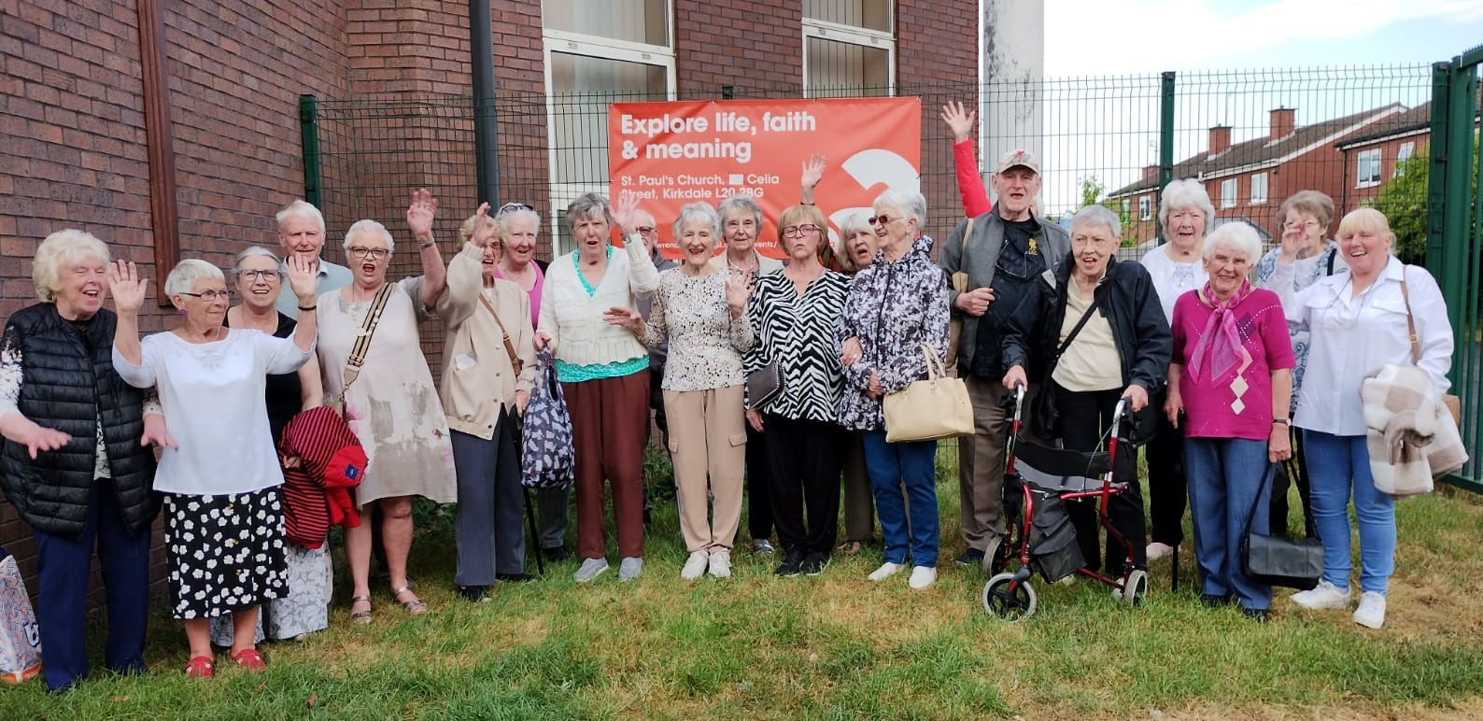  Young at Heart summer outing to Blist’s Hill, Shropshire
Our church halls are available to hire for Birthdays, Anniversaries, Community events and corporate events, and can be booked online at kirkdale.org.uk/venues
Find us  St. Lawrence, Westminster Close, Liverpool L4 1XB  St. Paul’s, 35 Celia Street, Liverpool L20 2BG  Email: admin@kirkdale.org.uk  Web: www.stlawrencewithstpaul.co.uk |  |  | Associate Priest, Rev’d Gill Hoy  Phone: 07561 686243

Service Rotas  We have a pool of people who help lead our services. This creates an opportunity for people to use their gifts or step out of their comfort zone to try something new. You are welcome to join our team of worship leaders for a short period of time, or you can make a longer commitment if you feel that is something the Lord is directing you to do.  Each person is given a particular Sunday each month (or more/less frequently if needed) either 10.30 am @ St. Lawrence Church or 6pm @ St. Paul’s Church. The services change each week so over the month we have a selection of different services which include Holy Communion and non-Eucharist services.  The options to choose from are:  • Leading the service (non-Eucharist),  • Preaching,  • Reading Scripture  • Preparing and reading prayers  Please see me if you would like to be included in our rotas or would like further information. Please pray for this important ministry for yourself and for others who are thinking about taking on a particular role. As we move forward and journey through the changes with the Lord’s help.  The ministers are responsible for the Services and reserve the right to make changes as and when needed.  Rev’d Gill Hoy  Thank you to everyone who donated to our Church Army Lent Appeal. We raised an amazing £405 which was gratefully received by Church Army. Many thanks. |  |  | Coffee morning  - Every Wednesday 9 to 11am at St. Lawrence  We welcome local residents to our church hall every Wednesday morning to socialise and discuss issues in our local community.  ALL ARE WELCOME.  Tea, coffee and biscuits are provided free of charge  Prayer and praise  - Every Wednesday between 12noon and 2pm at St. Lawrence  This is a wonderful time of fellowship and togetherness; we are blessed to be there and value being able to set time aside each Wednesday to be in God’s presence and worshipping our AMAZING God! Jesus said in Matthew 18 verse 20 “For where two or three are gathered together in my name, there I am with you”. We know this to be true because we witness it each week.  These meetings are a great opportunity to discuss, share, worship and pray so this is an open opportunity to anyone who feels they would like to join us. ALL ARE WELCOME.  We bring our own light lunch and drinks are provided. You are free to come along and take part or just listen and observe. We would love to see you and pray that you too will be blessed by the experience just as we are.
1/ |  |  | 6/

APCM  Annual Parochial Church Meeting  At our APCM on Wednesday 7th May the following people were elected to serve in this parish for the coming year.  Wardens Val MacLean, Don Rivers, Barbara Hughes  Safeguarding Officer Billy Barrow  Parochial Church Council  Liz Allan Billy Barrow  Bernie Garner Joe Kilshaw (Treasurer)  Lil Mulvey Pauline Worthy  The Wardens, Alison Tyrrell (as Secretary and Deanery Synod Representative) and Rev Gill Hoy also serve on the PCC as ex-officio members.  The Electoral Roll was agreed. We currently have 35 people on the roll, the list of names can be found on the noticeboards at both churches.  Thank you to all those elected for your willingness to fulfil these roles especially during our period of interregnum. Please pray that, as they carry out their duties, they will feel supported and enhanced in their vital ministry.  Almighty God, bless these officers and grant that they may be of service to our church and bring honour and glory to your name. We know you have plans for our parish and we trust that those plans are good. We pray that together we may discern your way for the future and be further equipped to grow your kingdom in this place. We ask this through Christ our Lord Amen. |  |  | The Birth of time zones  “God set these lights in the sky to light the earth, to govern the day and the night and to separate the light from the darkness, and God saw that it was good”  Genesis 1 verses 17-18.  In 1884, delegates from 25 nations met in Washington DC to agree upon an international standard for measuring time. They divided the earth into 24 time zones, beginning at the Prime Meridian, which runs through the Royal Greenwich Observatory, London.  The nations agreeing to this standard were only acknowledging and organizing for people what God had created long before the keeping of time. God, who never sleeps, watches over everything in the world 24/7 no matter what time zone we are in.  He organised the “lights” in the sky – the sun, moon and stars, and gave them to us to separate day and night. They stand as evidence of his great creative power and wisdom.  Prayer:  Creator God, each time we look up and see the sun and the moon may we be reminded of your sovereign wisdom and creativity through our universe. Amen  (Ellen Banks Elwell)
5/ |  |  | 2/

heaven  - LATEST TRAVEL INFORMATION  - Accommodation: Arrangements have been made for First Class accommodation.  JOHN 14:2 There are many rooms in my Father’s house, and I am going to prepare a place for you. I would not tell you this if it were not so.  - Passports: Persons seeking entry will not be allowed past the gates without proper credentials and having their names registered with the ruling authority.  REV 21:27 But nothing that is impure will enter the city, nor anyone who does shameful things or tells lies. Only those whose names are written in the Lamb’s book of the living will enter the city.  - Tickets: Your ticket is a written pledge that guarantees your journey. It should be claimed and its’ promises kept firmly in mind.  JOHN 5:24 I am telling you the truth; the time is coming – the time has already come – when the dead will hear the voice of the Son of God, and those who hear it will come to life.  - Customs: Only one declaration is required while going through Customs.  1 COR 15:1,3,4 And now I want to remind you, my brothers, of the Good News which I preached to you, which you received and on which your faith stands firm..  - Immigration: All passengers are classified as immigrants since they are taking up permanent residence in a new country. The quota is unlimited.  HEB 11:16 Instead, it was a better country they longed for, the heavenly country. And so God is not ashamed for them to call Him their God, because he has prepared a city for them.  - Luggage: No luggage whatsoever can be taken.  1 TIM 6:7 What did we bring into the world? Nothing! What can we take out of this world? Nothing!  - Air Passage: Travellers going directly by air are advised to watch daily for indications of imminent departure.  1 THES 4:17 Then we who are living at that time will be gathered up along with them in the clouds to meet the Lord in the air. And so we will always be with the Lord.  - Vaccinations: Injections are not needed, as diseases are unknown at the destination.  REV 21:4 He will wipe away all tears from their eyes. There will be no more death, no more crying or pain. The old things have disappeared.  - Departure Times: The exact date of departure has not been announced. Travelers are advised to be prepared to leave at short notice.  ACTS 1:7 Jesus said to them “The times and occasions are set by my Father’s own authority, and it is not for you to know when they will be”  From St Paul and Trinity U.R.C. Newsletter |  |  | YOUNG at HEART  Young at Heart Outing Blist’s Hill Victorian Village  We went on Monday 12th May 2025 on a Balmoral Coach to Blist’s Hill Victorian Village in Shropshire. DJ was our driver. There were 22 of us on the coach (including just 3 men); 2 relatives of mine who live nearby the village, met us there and made up our party to 24.  Blist’s Hill opened in 1973; it is an open-air museum Victorian town with buildings like a school, a doctors, a factory and a pub called the New Inn where a sing-song took place whilst we were there.  Some buildings had been taken down from the original site and rebuilt in the museum. All of the staff on the site are dressed in the attire of the day and you could go in the bank and exchange today’s money for the money then and buy things accordingly as you went around the site like 2d for a pint in the pub!  The village is not far from Ironbridge, which was the world’s first cast iron bridge built in 1779.  The weather was nice, although it threatened thunder for a bit. Everyone had an enjoyable time and DJ got us safely back to St Paul’s where Valerie took this group photo.  Don Rivers
3/ |  |  | 4/

